ASSIGNMENT 4
LAB: PYTHON PARALLEL PROGRAMMING
PRATIK ABHANG | 260740150018
AKANKSHA JADHAO | 260740150004

Exercise 1 – SCOOP
"""
Exercise 1: Distributed Scientific Computing with SCOOP.
Computes a Monte Carlo estimate of the integral of sin(x)*exp(-x)
on [0, pi], using 10,000,000 evaluations split into 16 chunks.
"""
import math
import random
import time
from scoop import futures
TOTAL_SAMPLES = 10_000_000
TASK_COUNT = 16
LOWER = 0.0
UPPER = math.pi
def evaluate_subrange(params):
subrange_id, samples_count = params
rng = random.Random(1000 + subrange_id)
max_y = 1.0
hits = 0
for _ in range(samples_count):
x = LOWER + (UPPER - LOWER) * rng.random()
y = max_y * rng.random()
curve_y = math.sin(x) * math.exp(-x)
if y <= curve_y:
hits += 1
return {
"subrange_id": subrange_id,
"hits": hits,
"total": samples_count,
}
def main():
base = TOTAL_SAMPLES // TASK_COUNT
remainder = TOTAL_SAMPLES % TASK_COUNT
task_workloads = []
for task_id in range(TASK_COUNT):
samples = base + (1 if task_id < remainder else 0)
task_workloads.append((task_id, samples))
start = time.perf_counter()
results = list(futures.map(evaluate_subrange, task_workloads))
distributed_time = time.perf_counter() - start
total_hits = sum(item["hits"] for item in results)
total_samples = sum(item["total"] for item in results)
# Area of rectangle = pi * 1.0.
estimate = (total_hits / total_samples) * math.pi
print("\n--- SCOOP Distributed Monte Carlo ---")
print(f"Total evaluations : {total_samples:,}")
print(f"Task chunks : {TASK_COUNT}")
print(f"Estimated integral: {estimate:.8f}")
print(f"Distributed time : {distributed_time:.4f} seconds")
start = time.perf_counter()
sequential_results = [
evaluate_subrange(item) for item in task_workloads
]
sequential_time = time.perf_counter() - start
seq_hits = sum(item["hits"] for item in sequential_results)
seq_total = sum(item["total"] for item in sequential_results)
seq_estimate = (seq_hits / seq_total) * math.pi
print(f"Sequential estimate: {seq_estimate:.8f}")
print(f"Sequential time : {sequential_time:.4f} seconds")
if distributed_time > 0:
print(f"Time ratio (seq/dist): {sequential_time / distributed_time:.2f}x")
if __name__ == "__main__":
main()
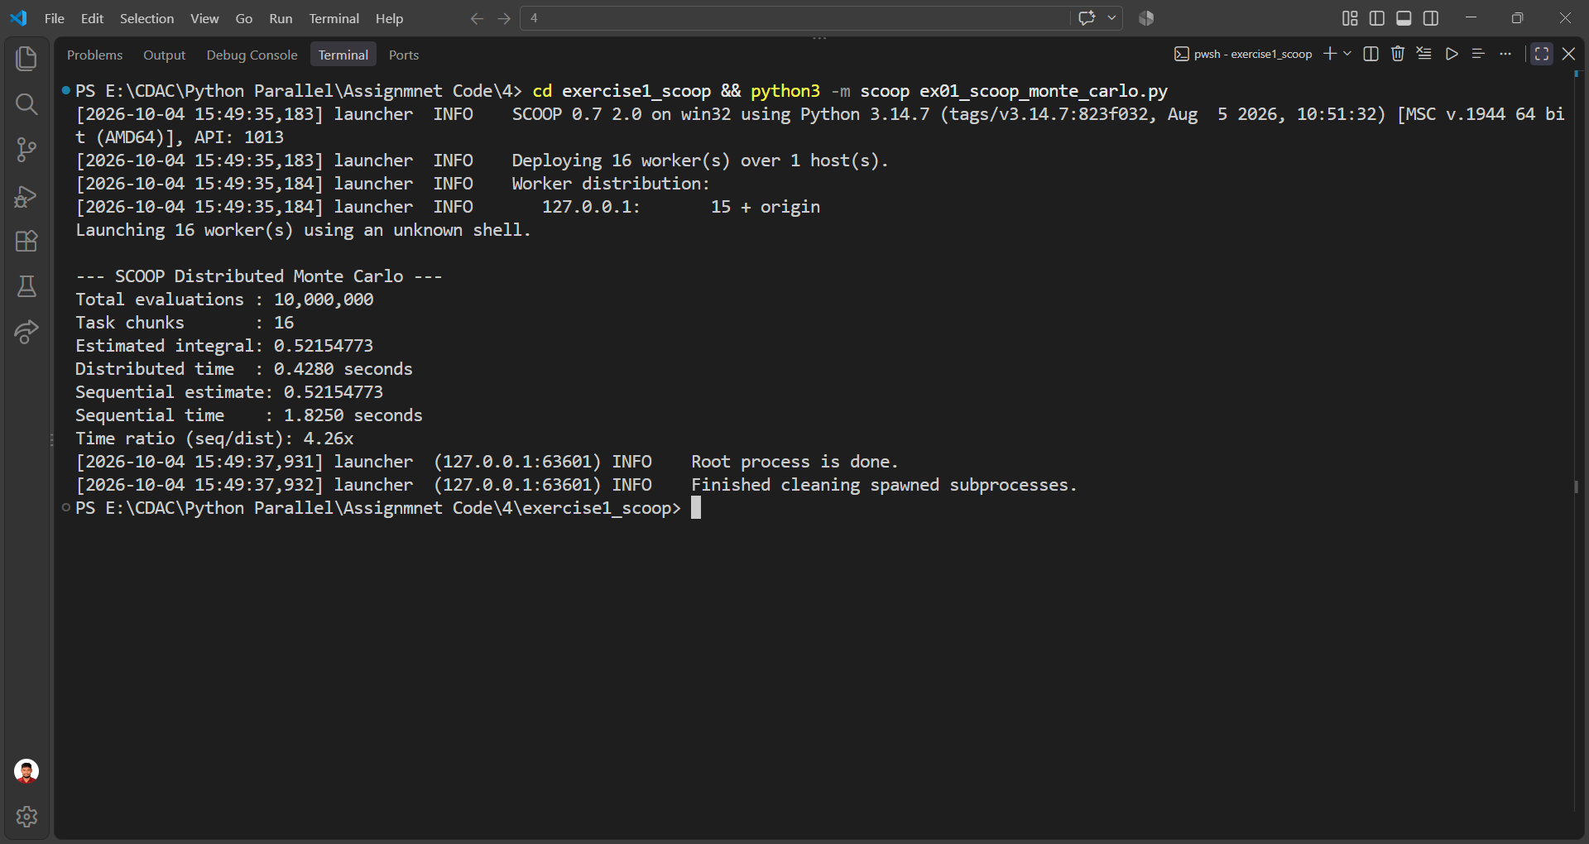

Exercise 2 – Pyro4 Server
"""Pyro4 server for the Remote Banking & Wallet Service."""
import Pyro4
@Pyro4.expose
class BankAccountService:
def __init__(self):
self.balance = 1000.0
self.transactions = ["Account opened with balance $1000.00"]
def get_balance(self):
return self.balance
def deposit(self, amount):
if amount <= 0:
return "ERROR: Deposit amount must be greater than 0."
self.balance += amount
self.transactions.append(
f"Deposited ${amount:.2f}; Balance: ${self.balance:.2f}"
)
return f"Deposit successful. New balance: ${self.balance:.2f}"
def withdraw(self, amount):
if amount <= 0:
return "ERROR: Withdrawal amount must be greater than 0."
if amount > self.balance:
return "ERROR: Insufficient funds."
self.balance -= amount
self.transactions.append(
f"Withdrew ${amount:.2f}; Balance: ${self.balance:.2f}"
)
return f"Withdrawal successful. New balance: ${self.balance:.2f}"
def get_statement(self):
return list(self.transactions)
def main():
daemon = Pyro4.Daemon()
uri = daemon.register(BankAccountService())
print("\nPYRO4 BANKING SERVER")
print(f"Bank Service URI: {uri}")
print("Keep this terminal running.")
print("Start the client in another terminal and paste the URI above.\n")
daemon.requestLoop()
if __name__ == "__main__":
main()
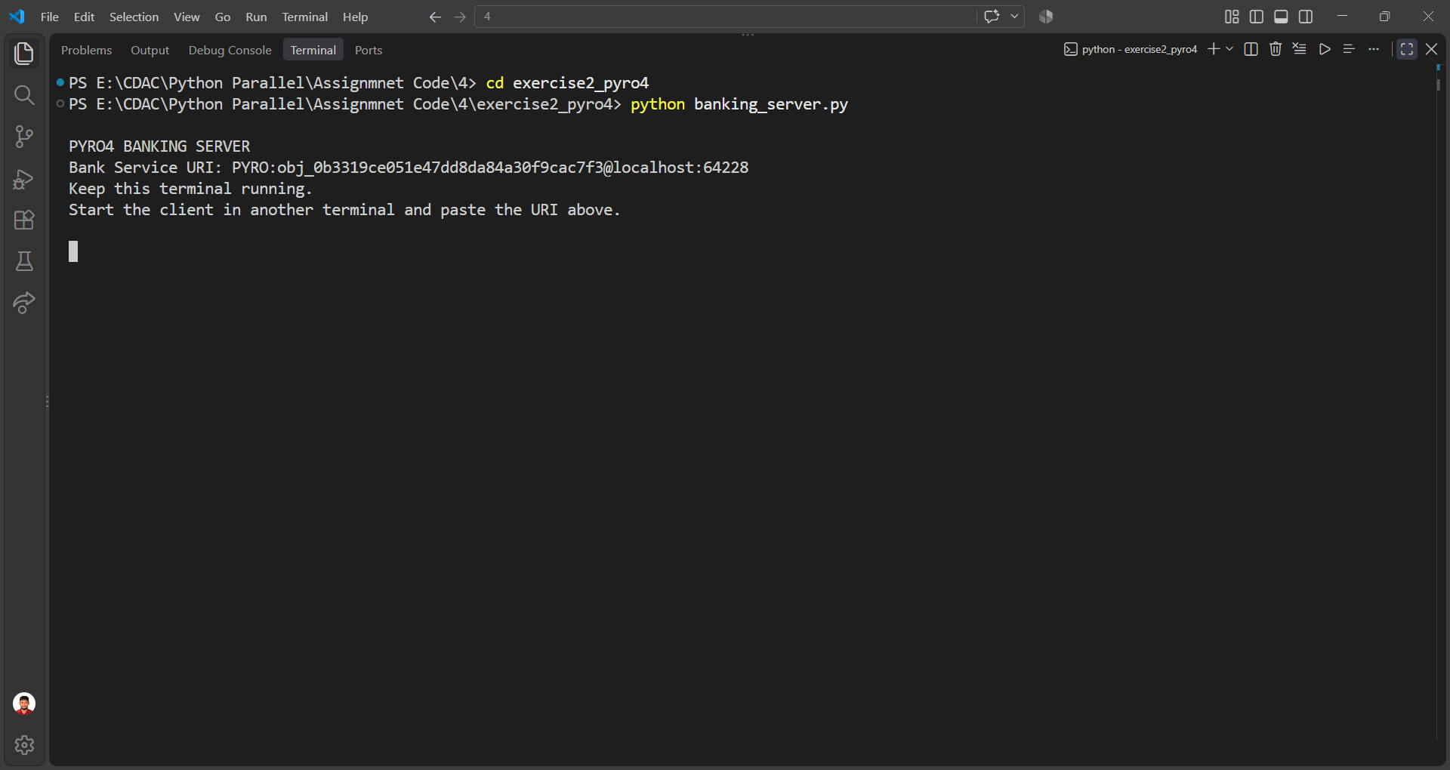

Exercise 2 – Pyro4 Client
"""Interactive Pyro4 client for the Remote Banking & Wallet Service."""
import Pyro4
def print_menu():
print("\n" + "=" * 50)
print("PYRO4 REMOTE BANKING SERVICE (CLI)")
print("=" * 50)
print("1. Check Current Balance")
print("2. Deposit Money")
print("3. Withdraw Money")
print("4. View Transaction Statement")
print("5. Exit Application")
print("-" * 50)
def main():
uri = input("Enter Bank Service URI (or paste from server): ").strip()
bank = Pyro4.Proxy(uri)
try:
while True:
print_menu()
choice = input("Enter your choice [1-5]: ").strip()
try:
if choice == "1":
print(f"Current Balance: ${bank.get_balance():,.2f}")
elif choice == "2":
amount = float(input("Enter deposit amount: "))
print(bank.deposit(amount))
elif choice == "3":
amount = float(input("Enter withdrawal amount: "))
print(bank.withdraw(amount))
elif choice == "4":
statement = bank.get_statement()
print("\nTRANSACTION STATEMENT")
if not statement:
print("No transactions found.")
else:
for number, transaction in enumerate(statement, 1):
print(f"{number}. {transaction}")
elif choice == "5":
print("Thank you for using the Remote Banking Service.")
break
else:
print("Invalid choice. Please select 1-5.")
except ValueError:
print("Invalid number. Please enter a valid numeric amount.")
except Pyro4.errors.CommunicationError:
print("ERROR: Could not communicate with the Pyro4 server.")
finally:
bank._pyroRelease()
if __name__ == "__main__":
main()
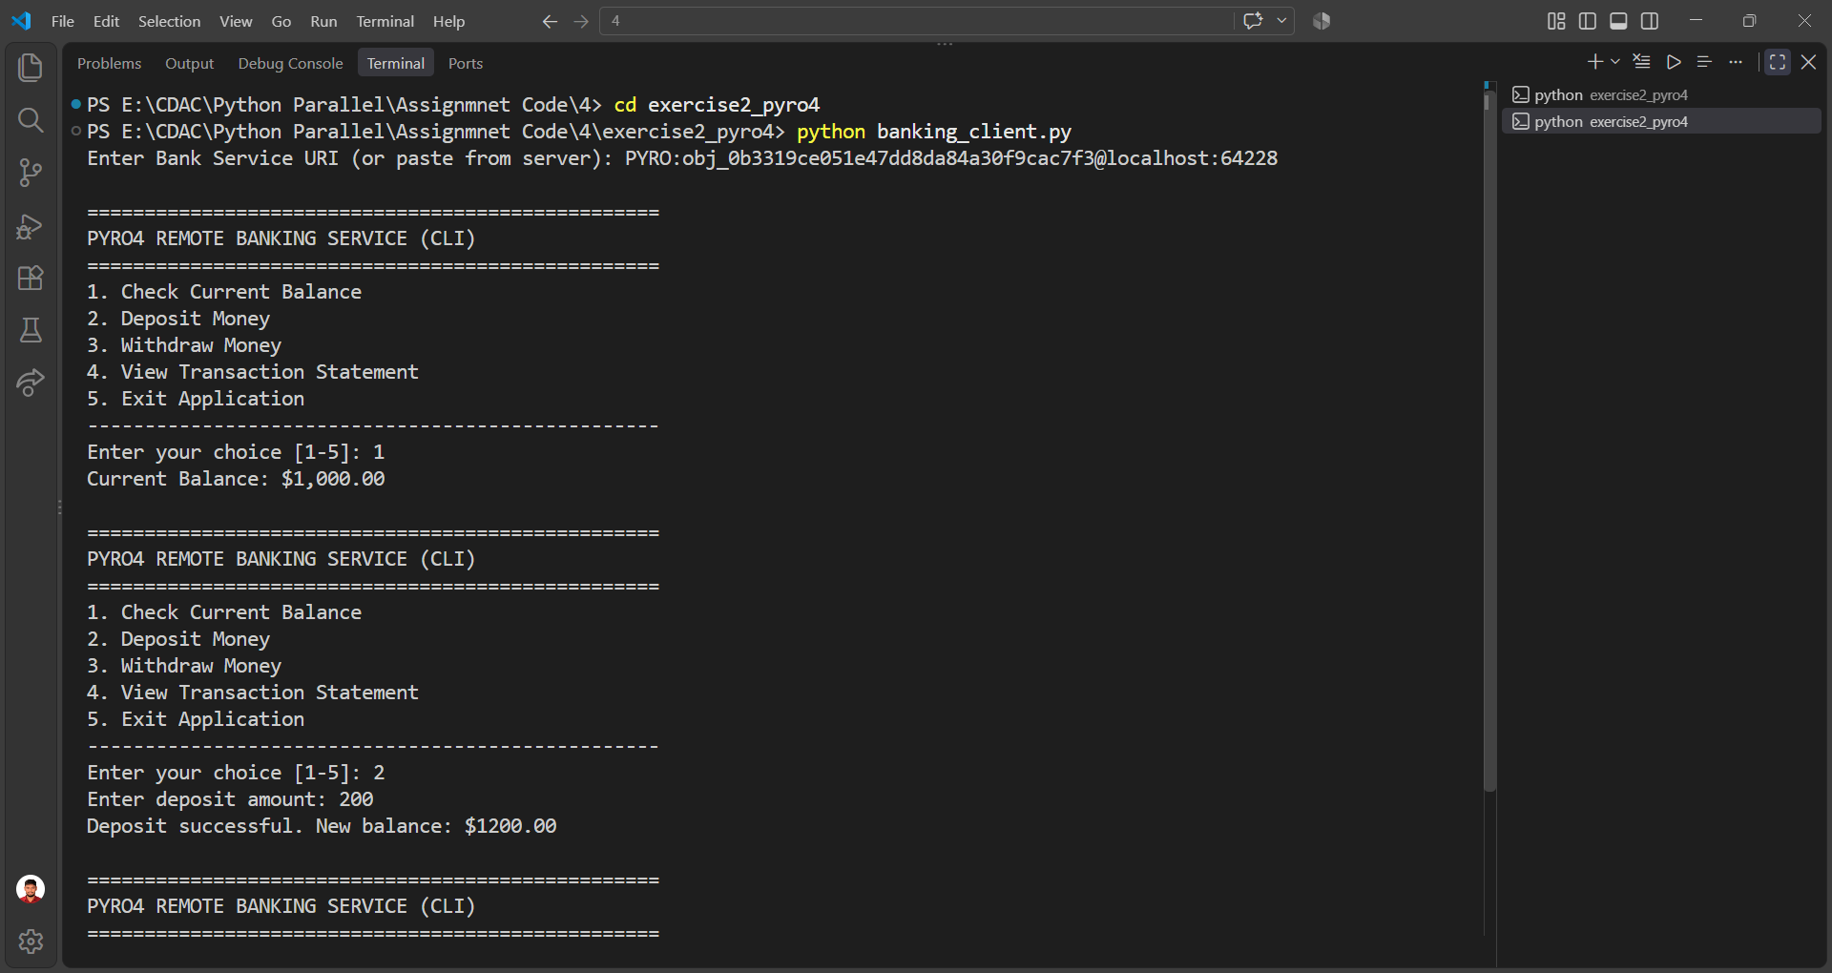

Exercise 3 – RPyC Server
"""RPyC server for Remote System Inspector & Math Utility."""
import ast
import math
import operator
import os
import platform
import time
import rpyc
from rpyc.utils.server import ThreadedServer
class SystemInspectorService(rpyc.Service):
def exposed_get_system_info(self):
return {
"system": platform.system(),
"release": platform.release(),
"hostname": platform.node(),
"cpu_count": os.cpu_count(),
"server_time": time.strftime("%Y-%m-%d %H:%M:%S"),
}
def exposed_list_files(self, directory_path="."):
try:
return sorted(os.listdir(directory_path))
except (FileNotFoundError, NotADirectoryError, PermissionError) as exc:
return [f"ERROR: {exc}"]
def exposed_compute_powers(self, base, max_exponent):
max_exponent = int(max_exponent)
if max_exponent < 0 or max_exponent > 100:
return {"error": "Exponent must be between 0 and 100."}
return {exponent: base ** exponent for exponent in range(max_exponent + 1)}
def exposed_execute_expression(self, expression_str):
"""
Safely evaluates basic arithmetic.
Supports numbers, +, -, *, /, //, %, **, parentheses,
and math.sqrt(...), math.sin(...), math.cos(...), math.tan(...).
"""
allowed_functions = {
"sqrt": math.sqrt,
"sin": math.sin,
"cos": math.cos,
"tan": math.tan,
"log": math.log,
}
try:
tree = ast.parse(expression_str, mode="eval")
return self._safe_eval(tree.body, allowed_functions)
except Exception as exc:
return f"ERROR: {exc}"
def _safe_eval(self, node, functions):
binary_ops = {
ast.Add: operator.add,
ast.Sub: operator.sub,
ast.Mult: operator.mul,
ast.Div: operator.truediv,
ast.FloorDiv: operator.floordiv,
ast.Mod: operator.mod,
ast.Pow: operator.pow,
}
unary_ops = {
ast.UAdd: operator.pos,
ast.USub: operator.neg,
}
if isinstance(node, ast.Constant) and isinstance(node.value, (int, float)):
return node.value
if isinstance(node, ast.BinOp) and type(node.op) in binary_ops:
left = self._safe_eval(node.left, functions)
right = self._safe_eval(node.right, functions)
return binary_ops[type(node.op)](left, right)
if isinstance(node, ast.UnaryOp) and type(node.op) in unary_ops:
value = self._safe_eval(node.operand, functions)
return unary_ops[type(node.op)](value)
if isinstance(node, ast.Call):
if (
isinstance(node.func, ast.Attribute)
and isinstance(node.func.value, ast.Name)
and node.func.value.id == "math"
and node.func.attr in functions
):
args = [self._safe_eval(arg, functions) for arg in node.args]
return functions[node.func.attr](*args)
raise ValueError("Only basic arithmetic and approved math functions are allowed.")
if __name__ == "__main__":
server = ThreadedServer(SystemInspectorService, port=18861)
print("RPyC System Inspector Server running on port 18861...")
server.start()
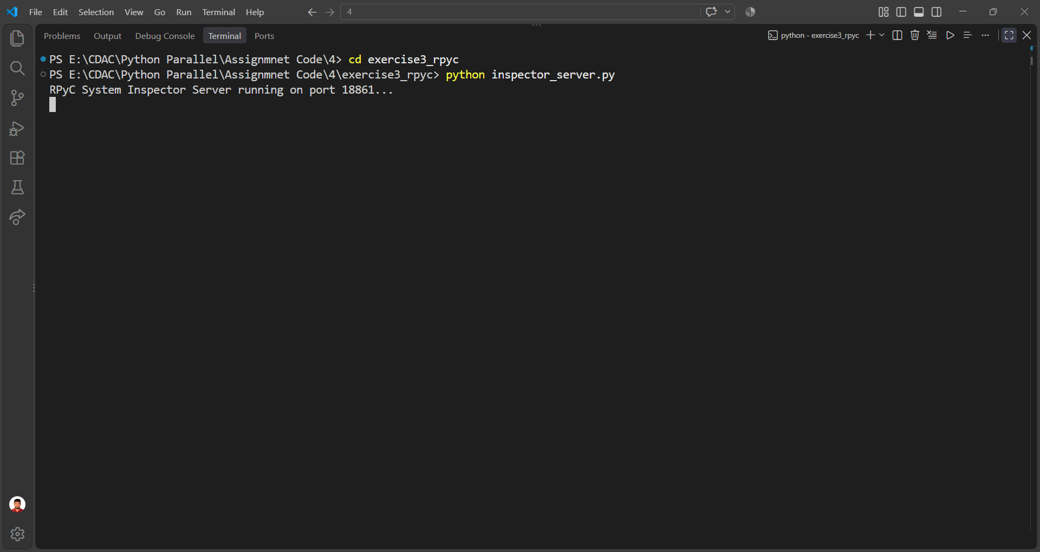

Exercise 3 – RPyC Client
"""Interactive RPyC client for the Remote System Inspector."""
import rpyc
def print_menu():
print("\n" + "=" * 50)
print("RPYC REMOTE SYSTEM INSPECTOR (CLIENT CLI)")
print("=" * 50)
print("1. Inspect Remote Host System Info")
print("2. List Files on Remote Directory")
print("3. Compute Exponential Table on Remote Host")
print("4. Evaluate Math Expression on Remote Host")
print("5. Disconnect & Exit")
print("-" * 50)
def main():
try:
conn = rpyc.connect("localhost", 18861)
service = conn.root
except Exception as exc:
print(f"Could not connect to RPyC server: {exc}")
return
try:
while True:
print_menu()
choice = input("Enter your choice [1-5]: ").strip()
if choice == "1":
info = service.get_system_info()
print("\nREMOTE SYSTEM INFORMATION")
print(f"OS : {info['system']}")
print(f"Release : {info['release']}")
print(f"Hostname : {info['hostname']}")
print(f"CPU Count : {info['cpu_count']}")
print(f"Server Time : {info['server_time']}")
elif choice == "2":
path = input("Enter remote directory [default=.]: ").strip() or "."
files = service.list_files(path)
print(f"\nFILES IN: {path}")
for name in files:
print(f"- {name}")
elif choice == "3":
try:
base = float(input("Enter base (e.g. 2): "))
exponent = int(input("Enter maximum exponent (e.g. 10): "))
table = service.compute_powers(base, exponent)
print("\nPOWER TABLE")
for exp, value in table.items():
print(f"{base:g}^{exp} = {value}")
except ValueError as exc:
print(f"Invalid input: {exc}")
elif choice == "4":
expression = input(
'Enter expression (e.g. "2**32 - 1" or "math.sqrt(144)"): '
).strip()
print("Remote result:", service.execute_expression(expression))
elif choice == "5":
print("Disconnected from RPyC server.")
break
else:
print("Invalid choice. Please select 1-5.")
finally:
conn.close()
if __name__ == "__main__":
main()
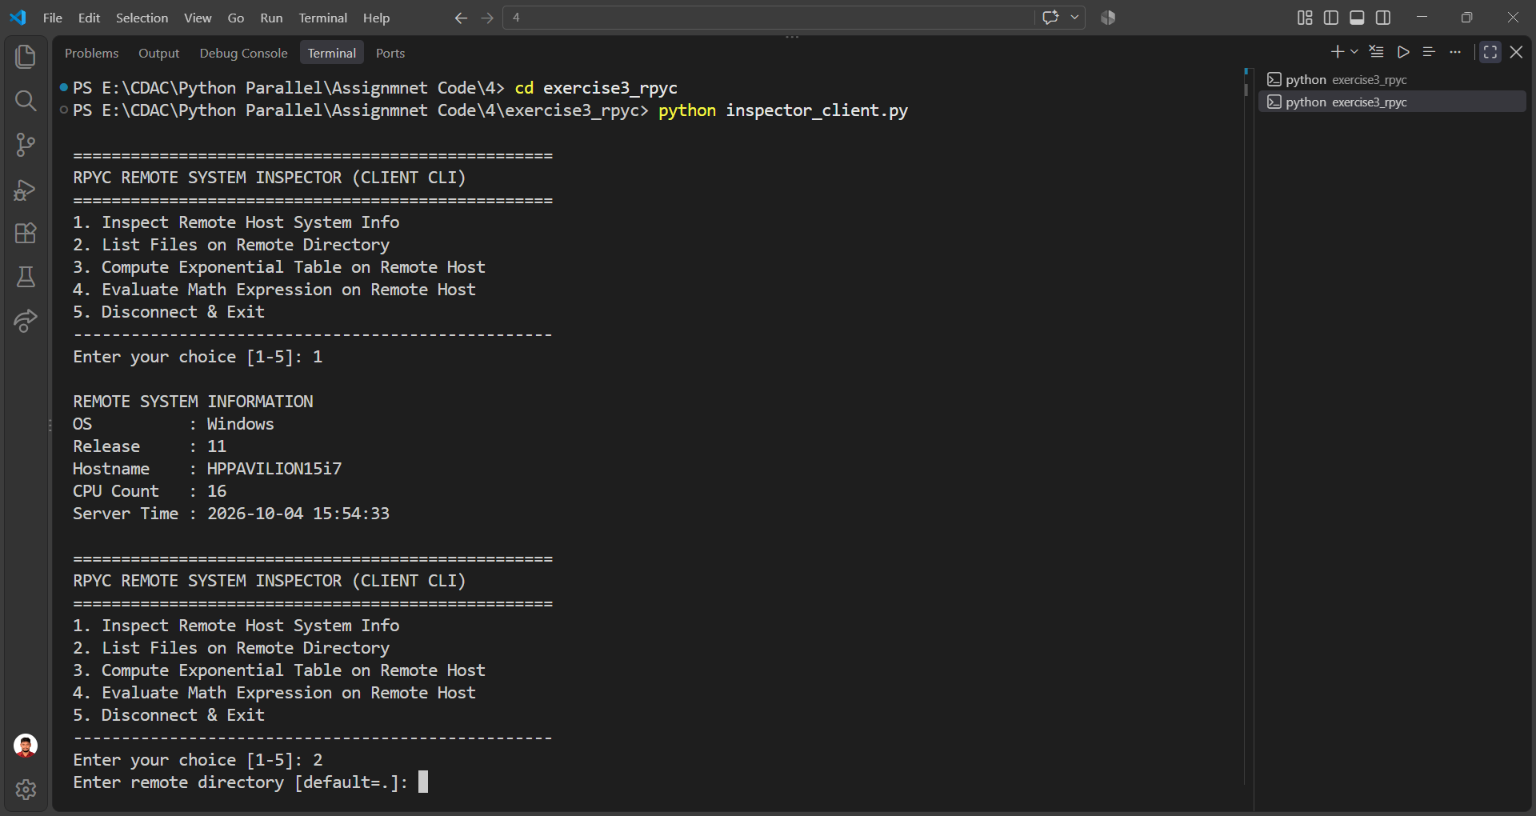

Exercise 4 – Celery Configuration
"""Celery configuration using Redis as broker and result backend."""
from celery import Celery
app = Celery(
"order_system",
broker="redis://localhost:6379/0",
backend="redis://localhost:6379/1",
)
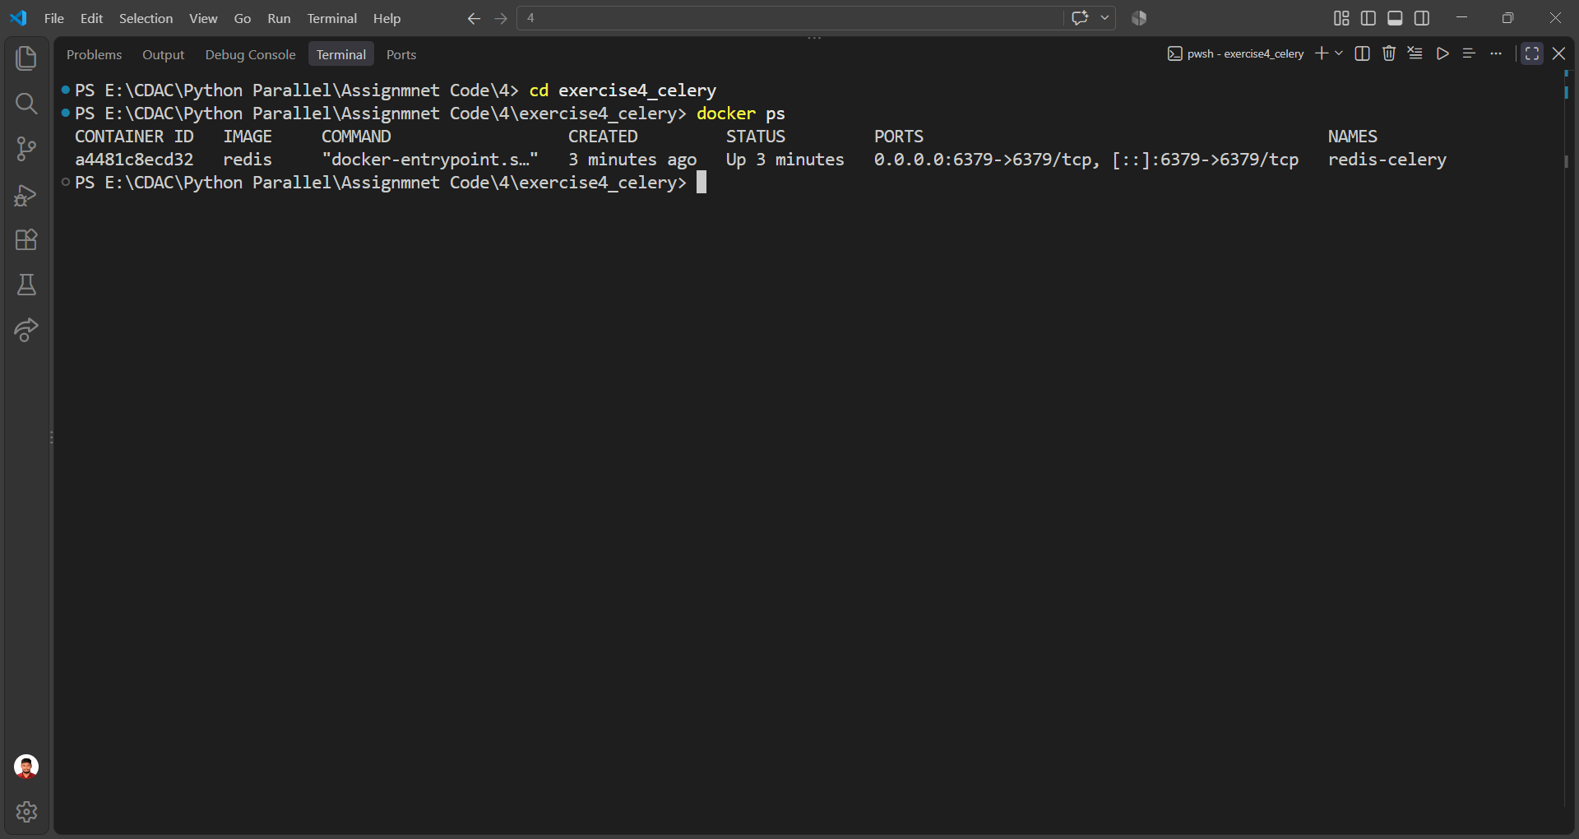

Exercise 4 – Celery Tasks
"""Celery tasks for the Order & Invoice Processing System."""
import time
from celery_config import app
@app.task
def validate_order(order_id, items, total_amount):
if not items:
raise ValueError("Order must contain at least one item.")
if total_amount <= 0:
raise ValueError("Total amount must be greater than 0.")
time.sleep(1)
return {
"order_id": order_id,
"status": "VALIDATED",
"items": items,
"total": float(total_amount),
}
@app.task
def calculate_tax_and_discount(order_data, tax_rate=0.18):
total = float(order_data["total"])
tax = total * float(tax_rate)
# No discount rule was specified in the assignment, so the final total
# is calculated as total + tax.
final_total = total + tax
updated = dict(order_data)
updated["tax"] = round(tax, 2)
updated["final_total"] = round(final_total, 2)
updated["status"] = "TAX_CALCULATED"
return updated
@app.task
def generate_invoice_pdf(order_data, customer_email):
time.sleep(2)
return (
f"Invoice #INV-{order_data['order_id']} generated and sent to "
f"{customer_email}"
)
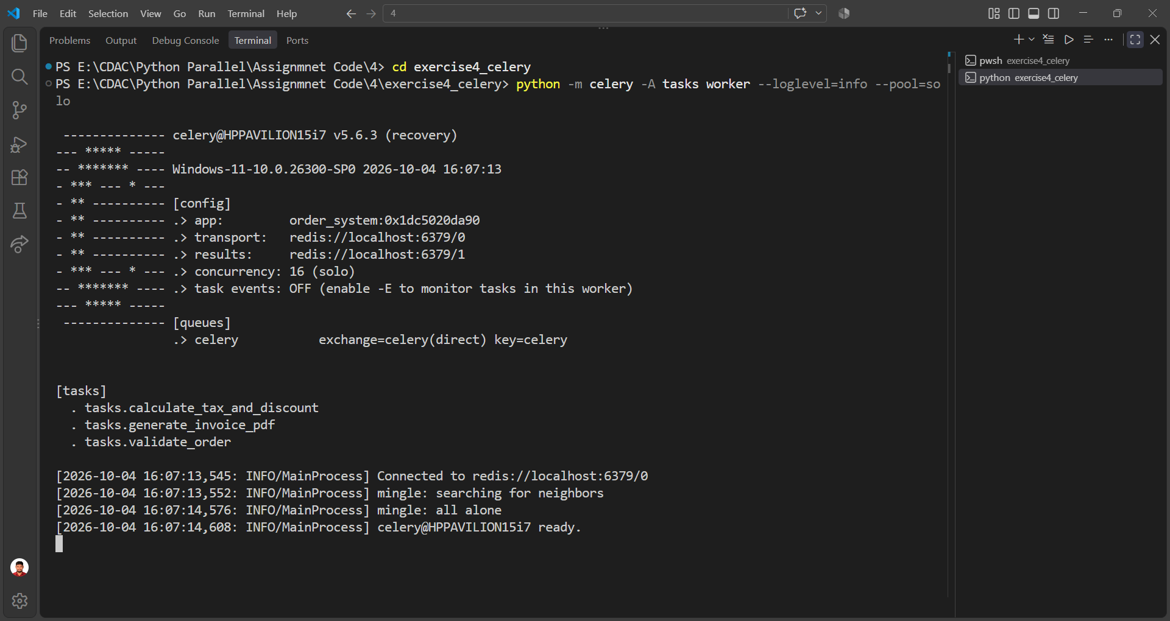

Exercise 4 – Celery Client
"""Celery client demonstrating independent tasks and a task chain."""
import time
from celery import chain
from tasks import validate_order, calculate_tax_and_discount, generate_invoice_pdf
def monitor_result(async_result):
print(f"Task Dispatched: {async_result.id}")
while not async_result.ready():
print(".", end="", flush=True)
time.sleep(0.5)
print()
if async_result.successful():
result = async_result.get()
print("Task Result:", result)
return result
print("Task failed:", async_result.failed())
return None
def main():
print("\n--- INDEPENDENT ASYNCHRONOUS TASKS ---")
orders = [
("ORD-101", ["Item A", "Item B"], 250.0),
("ORD-102", ["Keyboard", "Mouse"], 150.0),
("ORD-103", ["Monitor"], 300.0),
]
results = []
for order_id, items, amount in orders:
async_result = validate_order.delay(order_id, items, amount)
results.append(async_result)
for result in results:
monitor_result(result)
print("\n--- SEQUENTIAL CELERY CHAIN ---")
order_pipeline = chain(
validate_order.s("ORD-202", ["Laptop", "Mouse"], 1200.0)
| calculate_tax_and_discount.s(tax_rate=0.18)
| generate_invoice_pdf.s(customer_email="customer@example.com")
)
chain_result = order_pipeline.apply_async()
print("Pipeline submitted! Waiting for final invoice...")
final_msg = chain_result.get()
print("Pipeline Output:", final_msg)
if __name__ == "__main__":
main()
